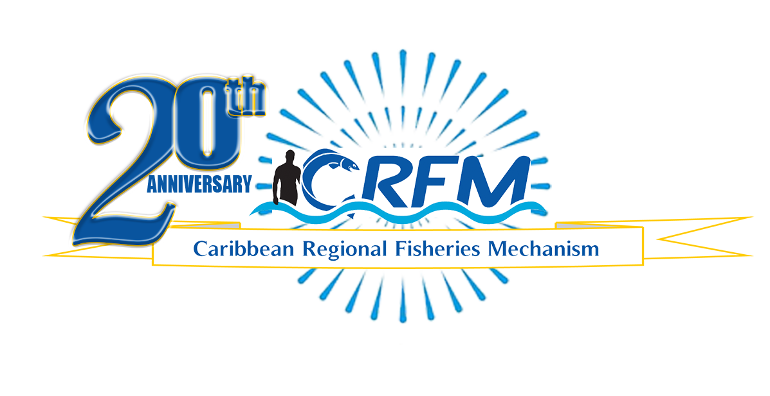
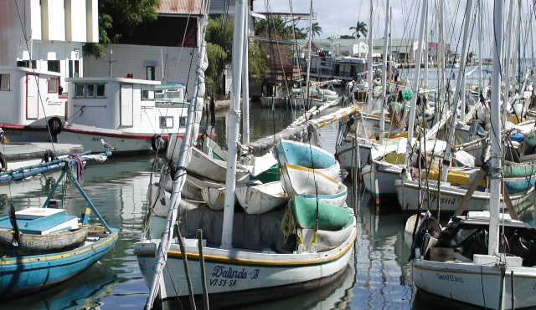

PRESS RELEASE

PR#001-2023
Towards Sustainable Development of
Fisheries for the People of the Caribbean!

Fish Assessment Scientist joins CRFM Team
Dr. Pranaya Kumar Parida

Belize City, Thursday, 19 January 2023 (CRFM)—The Caribbean Regional Fisheries Mechanism (CRFM) has a new fisheries assessment scientist on its technical team. Dr. Pranaya Kumar Parida, who holds a Ph.D. in Fisheries Resource Management from India with more than 18 years of experience in Fisheries Research, Teaching and Extension, was recruited to assume a three-year tenure with the CRFM through the longstanding Cooperation Programme between the Caribbean Community (CARICOM) and the Government of India.
Dr. Parida will assist the CRFM and its Member States with fisheries assessment studies, statistical analyses of commercially exploited marine fish stocks, as well as the formulation of fisheries management plans and advice for decision-making. He will also provide training to Fisheries Biologists, Data Collectors, and Data Managers in CRFM Member States and at the CRFM Secretariat. He will be based at the CRFM Office located in St. Vincent and the Grenadines.
Milton Haughton, Executive Director of the Caribbean Regional Fisheries Mechanism said: “The recruitment of Dr. Parida to assist with stock assessment studies is expected to provide critical data and information on the state of our fisheries, enabling CRFM Member States to enhance the way they manage the region’s fisheries resources. Through this engagement, the CRFM will continue to work towards strategically improving the sustainable development and management of the living marine resources of the CARICOM and CRFM Member States. The CRFM Secretariat is very grateful for the generous support being provided by the Government of India in making the services of Dr. Parida available to the CRFM Member States.”
He is credited with the publication of more than 35 international peer-reviewed research papers, 10 popular articles, and 2 books. He has been awarded a design patent and has filed another 4 patents as co-inventor.
Dr. Parida previously served as Assistant Professor (Fisheries Resource Management) at College of Fisheries, GADVASU, Ludhiana. He has furthermore conducted over 50 training programmes for the farmers, students from different universities, and government officials from different states of India.

—ENDS—
ABOUT THE CRFM:

The Caribbean Regional Fisheries Mechanism (CRFM) was officially inaugurated on 27 March 2003 in Belize City, Belize, where it is headquartered, following the signing of the Agreement Establishing the CRFM on 4 February 2002. It is an inter-governmental organization whose mission is to promote and facilitate the responsible utilization of the region's fisheries and other aquatic resources for the economic and social benefits of the current and future population of the region.
PRESS CONTACT NAME: Milton Haughton, Executive Director PHONE: 501-223-4443
E-mail: milton.haughton@crfm.int

